Ebike For Sale
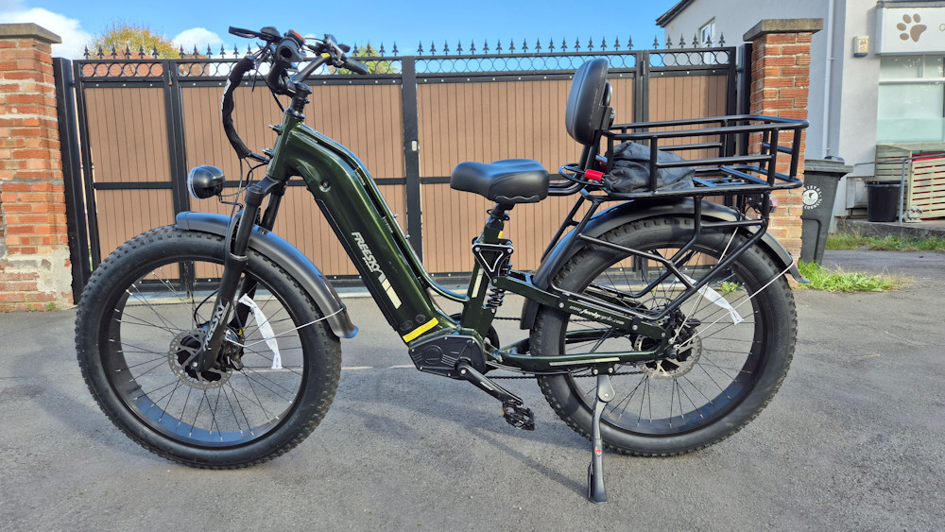
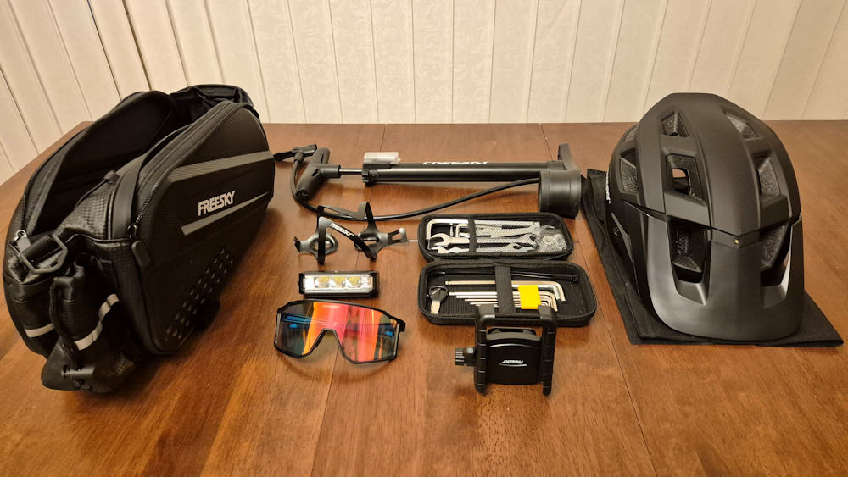 | • Nearly new Freesky Ranger Air ebike  • 126 miles only  • Fully built  • Comes with basket, two locks, helmet, toolkit and more

Price: £1,100
Including all the extras
Ring Debbie on 07977 418184
or just ring the bell on my front door in the lane for a viewing

